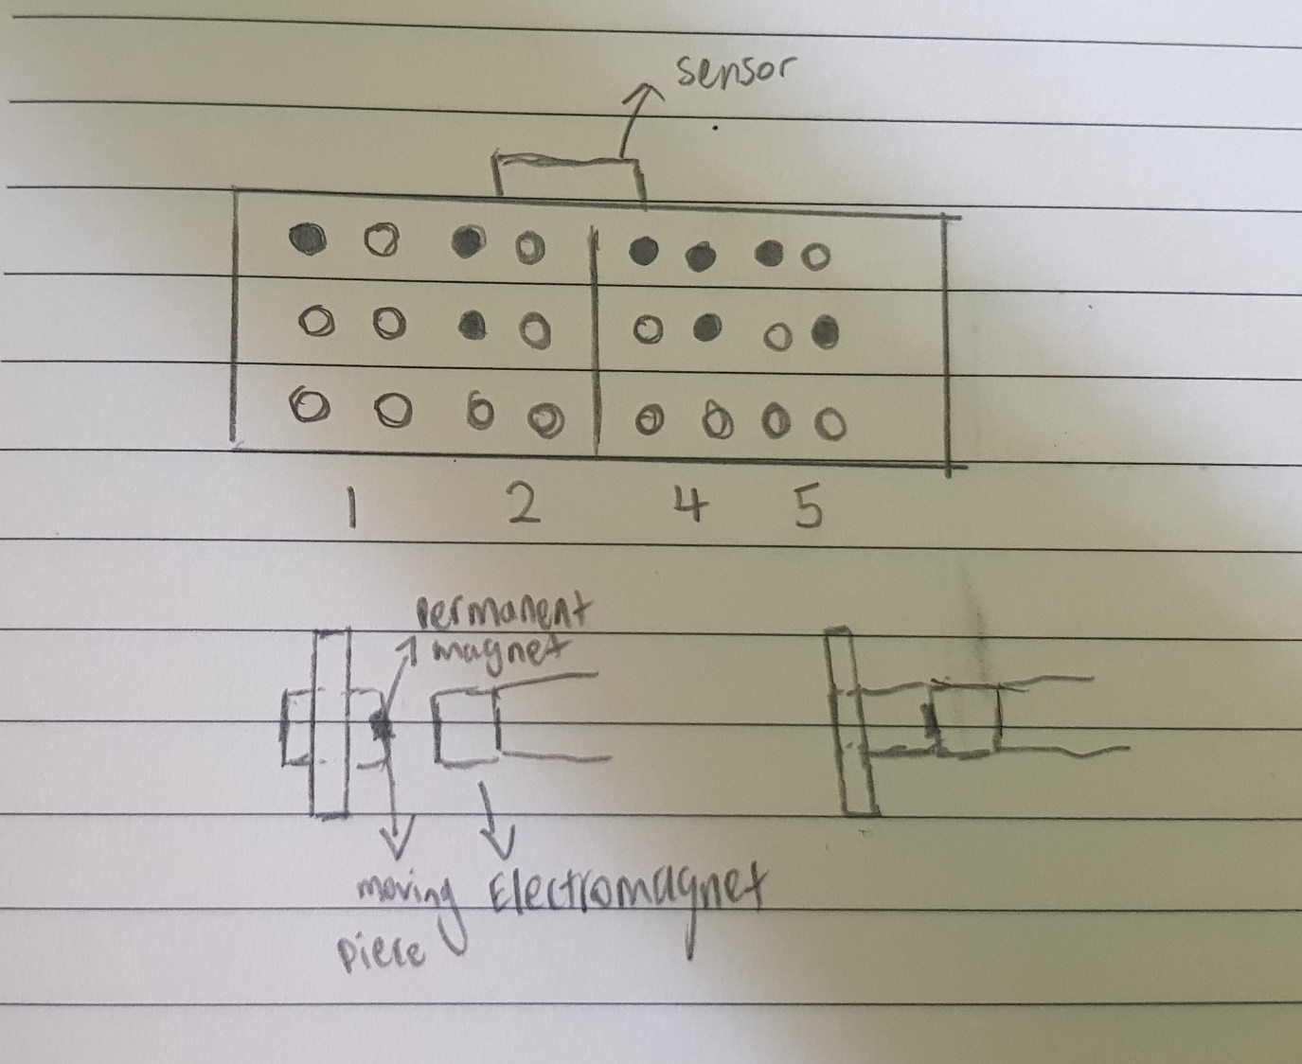

A braille clock for the visually impaired. How it will work is that there are 24 movable blocks representing the braille numbers. These will move in or out based on the corresponding time. The movement is controlled by an electromagnet that activates and repels based on the correct braille conversion given for the time.

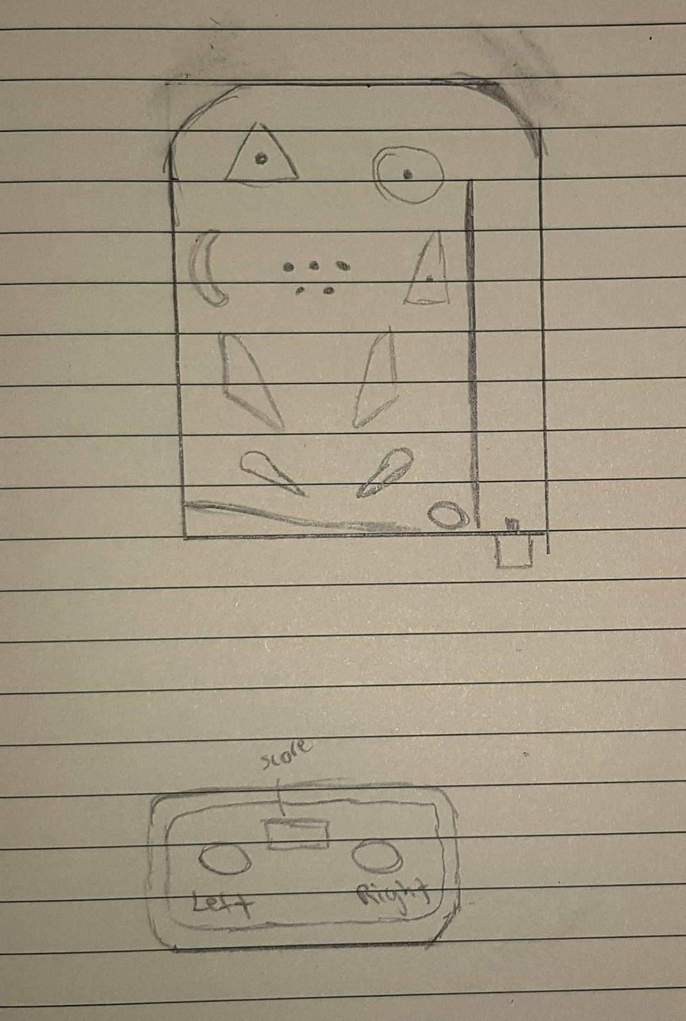

An IoT Pinball machine. The pinball machine itself is physical. However, the controls are controlled by a smartphone connected to an ESP32 microcontroller.